# Data Centric RAD

## Lab 2 MySQL Review II

### Part 1

* Get superheroes_wk2.sql from Moodle.
* Import it into MySQL as follows:
  + Go to the following directory in the cmd tool: wamp64\bin\mysql\mysql5.7.9\bin
  + Run the following command:

mysql -u root -p < "*<Full Path >*\superheroes_wk2.sql"

* use superheroes;
* Insert the following information into the superhero_table:

name = Penguin

City = Gotham City

Real First Name = Danny

Real Surname = DeVitto

dob = January 14th 1955

powers = 44.57



* Insert the following information into the superhero_table:

name = Joker

city = New York

powers = 77.10



* Update the superhero_table so that everywhere a first name or surname is NULL, it is now UNKNOWN instead.

HINT: When checking for NULL, you can’t say = NULL, you should say is NULL.

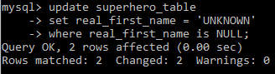

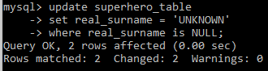

*or*

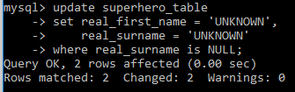

* Display the number of superheroes, whose birthdays are known, as ‘Number of known Birthdays’.

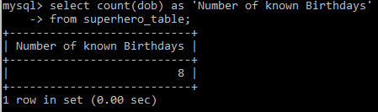

* Change the birthday of Spiderman from Metropolis to January 28th 1980.

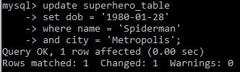

* Increase the powers by 1 for each ‘Bat’ related superhero in Gotham City.

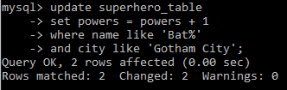

* Delete all superheroes whose *dob* is NULL.

HINT: When checking for NULL, you can’t say = NULL, you should say is NULL.



* Delete all superheroes whose real first name is *Bruce*, and who live in *Metropolis* and who were born in *January*.

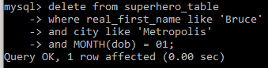

* Increase the powers of all superheroes who were born in *November* by 1.

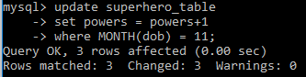

* Display the name, real first name, real surname and dob (as *Oldest DOB*) of the *oldest* superhero.

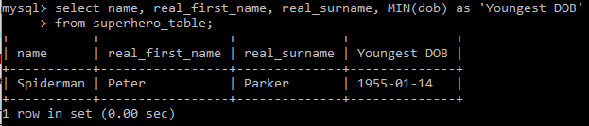

* Display the total powers (as *Total Metropolis Powers*) of all superheroes in *Metropolis*.

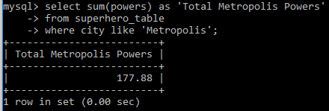

* Display the city and the total powers (as *Total Powers*) of all superheroes in the city, for each city.

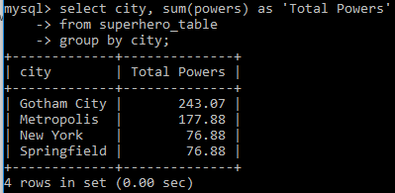

* Display the superhero name, and the number of cities a superhero of that name lives in.

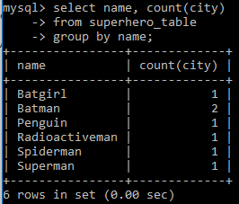

* Display the year and the number of superheroes born in that year.

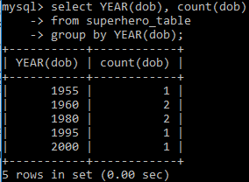

* Display the city and the total powers of all superheroes in that city, only for cities whose total superhero powers is greater than 100.

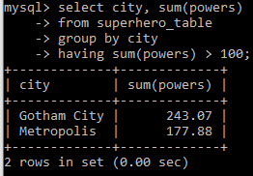

* Show the minimum, maximum and average powers of the superheroes.

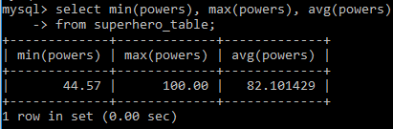

* Show the city and the average powers of all superheroes in that city; for all cities.

